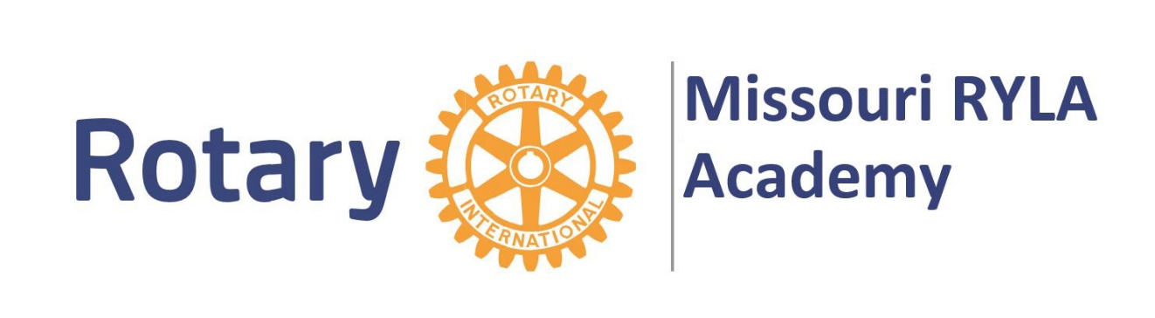

Hello from the Missouri RYLA Academy!

Congratulations on your selection to attend a session of MO RYLA 2019! Mark your calendars for the session you registered for:
Session 1: Sunday, June 23rd to Wednesday, June 26th
or
Session 2: Sunday, July 7th to Wednesday, July 10th
We are pleased that you have accepted the opportunity to be a part of one of Rotary’s finest youth leadership development programs in the world. The RYLA program has been implemented in Missouri since 1992, with over 2,500 students participating.
You have been recognized as a student who has illustrated service in your personal life, school and community.
Servant leadership is the fundamental core of Rotary International. Developed by some of Missouri's top professional educators, our curriculum is designed to identify and enhance qualities you have already exhibited.
MO RYLA has a special spirit about it. Close to 100 students per academy from around the state of Missouri meet, learn and bond. It is a leadership experience like no other. These participants are a lot like you…with hearts of service.

Please note the following information:

Check in will be the Sunday of your session (Session 1 or 2) from 4-5 pm at the Dome Building on William Woods University Campus in Fulton, Missouri.
Transportation is the responsibility of your family. If that is a concern, contact your local Rotary club.
Check out will be after 4 pm on Wednesday night. Be sure to note the “Participant Info” link for additional information.

Welcome to the RYLA family! If you or your family has any questions, please feel free to contact me.
We can’t wait!

Valerie Anderson, Administrative Director
missouriryla@gmail.com
816.673.6818

